# Revised proposal

# IT Project Proposal: CCBnB Accommodation Platform

Submitted date: Dec. 4, 2023

Submitted by: Group 6 – Bowen Dai & Shu Jin

# Project Introduction

The CCBnB Accommodation Platform is an advanced online room rental service that aims to revolutionize the booking experience for hosts and guests. This project focuses on leveraging modern technology to create a secure, efficient, and user-friendly platform in the rapidly evolving online accommodation market.

# Project Objectives/Goals

1. Enhanced Security: Implement top-tier security measures for user data and transactions.

2. User-Centric Design: Offer an intuitive and responsive user interface for seamless interaction.

3. Scalable Architecture: Build a robust system capable of handling growth and integrating new features.

4. Market Penetration: Establish CCBnB as a premier choice in the online accommodation market.

# Project Target Customers

- Hosts: Property owners looking for a dynamic and secure platform for property management.

- Travelers: Users seeking a reliable and straightforward platform for booking accommodations.

# Project Features

### Must-Haves:

1. Intuitive User Interface: Streamlined interfaces for ease of use.

2. Secure Third-Party Integrations: Enhanced functionality through external services.

### Nice-to-Haves:

1. Customizable Guest Experience: Tailored features for an enhanced stay.

2. Analytics for Hosts: Insights to optimize pricing and maximize occupancy.

3. Host Management App: Tools for hosts to manage properties and track earnings.

4. Advanced Security Features: Robust door-lock security and data protection.

# Projected Project Tools & Resources

### Hardware:

- Cloud servers hosted on AWS ECS for scalability and reliability.

- Cloud server - pgsql server

- google cloud - apigee proxy server

### Software:

- Backend: ASP.NET with REST API architecture.

- Frontend: React for a dynamic and responsive user interface.

- Database: Cloud-hosted PostgreSQL (chosen for cost-effectiveness over MSSQL).

- Google Apigee for API management and secure proxy.

- Entity Framework for database ORM, compatible with PostgreSQL, MySQL, and MSSQL.

- Development Environment: Visual Studio 2022.

### Other Resources:

- Integration with AWS services for hosting and scaling the application.

- Use of third-party APIs for additional functionalities.

# Project Challenges

1. Complex Integrations: Seamlessly integrating diverse systems like AWS, Google Apigee, and third-party APIs.

2. Data Security and Compliance: Ensuring the protection of user data in line with global standards.

3. User Interface Usability: Designing an interface that caters to diverse user needs while maintaining simplicity.

4. Scalability and Performance: Building a platform that can efficiently handle increasing loads and user growth.

# Project Architecture

The CCBnB Accommodation Platform is architected to provide a seamless, secure, and efficient online room rental experience for both hosts and guests. The system is built using a combination of modern web technologies and cloud services to ensure scalability, reliability, and performance.

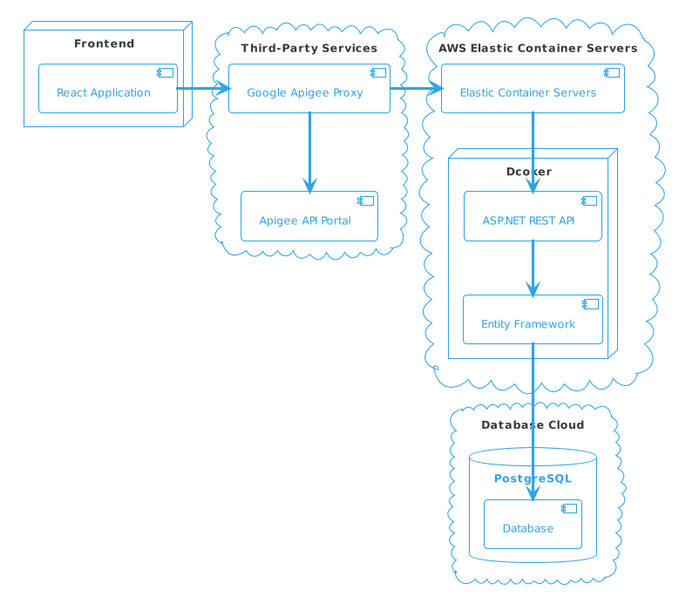

## System Architecture Overview

- Frontend (React Application): This is a user interface built using React, providing an interactive experience for the users. It communicates directly with the Google Apigee Proxy to interact with backend services.

- Google Apigee Proxy: Serves as an API gateway, handling requests from the frontend application. It adds an additional layer of security, manages API traffic, and enables potential API transformations.

- AWS Elastic Container Servers: Hosts the containerized ASP.NET applications and related services. Utilizing AWS ECS enhances the scalability and reliability of the application.

- Docker: Containerization technology used to encapsulate the ASP.NET REST API and Entity Framework, ensuring consistent deployment and runtime environments.

- ASP.NET REST API: Forms the core of the backend services, processing requests from the frontend, executing business logic, and communicating with the database.

- Entity Framework: Acts as an Object-Relational Mapper (ORM), facilitating interactions with the PostgreSQL database.

- PostgreSQL (Database Cloud): A cloud-hosted database that stores application data such as user information, room details, and booking records.

This architecture leverages cloud services and modern technologies to provide a highly scalable, secure, and high-performance platform suited for the online room booking market. The separation of the frontend application from backend services, coupled with the use of an API gateway and containerization technology, ensures high security and maintainability of the platform.